WaRe – Waterfront Regeneration
Learning from European best practices for a sustainable urban life

Venice, May 5th – 6th, 2013

INFORMATION PACK

ACCOMODATION

A room for each participant has been pre-booked by Cities on Water at:

• Patronato Salesiano Leone XIII (for partners coming from Slovenia and Czech Rep.)
• Antica Locanda Montin Snc (for partners coming from Portugal).
Please mention the ‘WaRe’ project reservation when you confirm.
Each partner will pay the room with the Grundtvig budget at departure.

FROM THE AIRPORT TO THE HOTEL

For Patronato Salesiano Venezia

Patronato Salesiano Leone XIII (Calle San Domenico 1281 – Castello, 30122 Venezia, tel. +39 041 5230796, email: info@salesianivenezia.it ) is located close to the Giardini della Biennale, in the district (sestiere) of Castello. It is a religious structure organised also to welcome tourists and visitors.

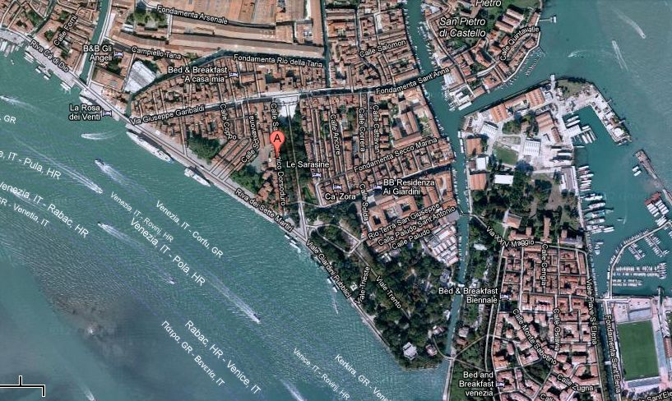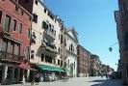

it is possible to arrive at the “Zattere” stop by choosing the Alilaguna linea blu boat service (www.alilaguna.it) or choosing the Alilaguna linea arancio till the “Ca’ Rezzonico” stop; cost of the ticket one way 15 € - round trip 27 € (online 14 € and 25 €).

30122 Venezia
tel. (+39) 041 5298711
fax (+39) 041 5230399
Email: info@turismovenezia.it
http://www.turismovenezia.it/eng/

Marco Polo Airport: www.veniceairport.it/

Trains: www.trenitalia.com/

If some of you is planning to stay longer and visit the city, please note that you can have a packet of services at reduced price with the “Venice Card” which includes public transportation, entrance to museums. Please note that you have to buy it in advance on line at the website: www.venicecard.it.

CONTACTS

Ms. Marta Moretti

+39 349 4594520

marta.cittadacqua@libero.it

